**1.1 Background and Project Vision**

High Intensity Training (HIT) also known as High intensity interval training (HIIT) is widely recognized for its health benefits. HIT is a form of cardiovascular exercise using short periods of intense anaerobic exercise with shorter recovery periods. Many applications are available to assist with HIT. At this time none are monitoring the end user’s physiological response to the training. This proposes a problem for many users trying to seek health benefits and weight loss. These individuals are unable to get effective and consistent results from their training leaving them unable to reach the health goals they have set. Professionals from the health and fitness industry are also having problems.

Due to the lack of physiological feedback these professionals are unable to devise effective HIT workouts consistently. The American Heart Association generally recommends a heart rate of 50% to 70% of your maximum heart rate for exercise that is considered moderate intensity and 70 to 85% for exercise intensity that is considered vigorous. A simple way to calculate one’s maximum heart rate is to simply subtract your age from 220. For example, an individual that is 20 years old has a maximum heart rate of 200.

A [2013 study](http://heart.bmj.com/content/99/12/882.full?sid=90e3623c-1250-4b94-928c-0a8f95c5b36b) tracked the cardiovascular health of about 3,000 men for 16 years and found a high resting heart rate was linked to poor health such as higher blood pressure, high body weight, levels of circulating blood fats as well as poor overall general physical fitness. It was also discovered that the higher a person’s resting heart rate, the greater the risk of premature death. A resting heart rate of 81-90 doubled the chance of death while a resting heart rate of 90 tripled it.

A [2010 study](https://bjsm.bmj.com/content/44/Suppl_1/i20.2) tracked the effects of exercise on resting heart rate and its correlation to blood pressure and other coronary artery disease. 12 CAD patients were randomized to HIT training with an exercise intensity of 65-75% of maximum rate over the course of 8 weeks. Results showed that HIT significantly lowered the resting heart rate of these patients.

Our goal with this project was to target individuals who are trying to get healthier and trainers who would like a more advanced tracking/response feature for their clients and address the issues previously stated. Our solution involves offering trainers the tools to adapt and customize their plans for their client based on the client’s oral and physiological feedback via heart rate information.

**1.2 Socio-economic Impact, Business Objectives, and Gap Analysis**

Socio-economic impacts include, the ability for trainers to provide a surefire way to affect an individual's health. With heart rate feedback and information from workouts they’ve created and assigned, they will be able to adjust the workout to better suit their client’s needs and guarantee results. Unfortunately, FitBits will be needed in order to do so. Without the FitBits, trainers will be unable to get the physiological feedback from their clients in order to provide guaranteed health benefits. Trainees who enroll in our app will get health benefits from its use, and the previous information can back up this claim.

Our business objective is a non profit one. We simply wish to create a visually appealing and functional app, that will provide health benefits to the trainees using it as well as make trainer’s jobs easier to accomplish. With this project we also wished to expand our skill set and bring more familiarity with this entire process. We hope that after graduation this project will add to our existing knowledge and allow us to make a strong impact in a CS/IT environment.

Gap Analysis(WIP)

**1.3 Security and Ethical Concerns**

Project road bumps are a common thing in a project of this scale. Instead of shifting blame during any obstacles, the project team banded together to come up with a solution to overcome said obstacle. It is not uncommon for projects to not always go as planned but it was important for us to find solutions to these obstacles in order to get the project back on track.

Security Concerns(WIP)

**1.4 Glossary of Key Terms**

**High Intensity Training:** A form of interval training, a cardiovascular exercise strategy alternating short periods of intense anaerobic exercise with less intense recovery periods, until too exhausted to continue.

**Maximum Heart Rate:** The maximum number of beats made by your heart in 1 minute of effort

**Anaerobic Exercise:** Any activity that breaks down glucose for energy without using oxygen. Generally, these activities are of short length with high intensity.

**Resting Heart Rate:**  Defined as the number of times your heart beats per minute while at complete rest.

**CAD(Coronary Artery Disease):** Plaque buildup in the wall of the arteries that supply blood to the heart

**2.1 Team Information**

Team members included Andrew an IT student, Sam a CS student, Rafy a CS student, Daniel a CS student, Parth a CS student, and Julian a CS student as well. Andrew being an IT student didn’t have much experience in software development aside from the basic intro classes he took early in his years, so all this was new and challenging to him. **(Other group members write something about themselves here).**

**2.2 Tools and Technology**

Tools and Technologies included in this project are Github/Git for version control. Adobe XD for wireframes and some mockups. Discord to communicate and to meet. Firebase and Mongodb for our database. Our front end would also be hosted on firebase. Google cloud was used for our backend server. Our backend would be hosted through there on Windows Server 2019. React, React Native, Nodejs, as well as Redux would be used in the development of this project. These were the tools and technologies we decided to use to help us on this project for the semester. Some of us were new and unfamiliar with some of these technologies so often the veterans who recommended them would aid us with any questions regarding the use of them. This helped smooth out the learning curve of some of the technologies.

**2.3 Project Plan**

Our project plan included splitting up into different teams for the development of this project. Parth and Julian would work on the mobile application, Sam and Daniel would work on the web application, Rafy would work on the backend of this project, and Andrew would work on the UI recommendations of this project as well as the backend server setup. With this everyone could work on the project in accordance to their strengths. We would also meet one to two times a week to discuss project progress and challenges, as well as constant communication via text through our discord channels. This ensured proper communication in this project to make sure everyone was on the right track.

**2.4 Best Standards and Practices**

It was encouraged to be as transparent as possible while working on this project, as the smallest things could cause big obstacles during the development process. Whether it was unfamiliarity with a certain technology or if it was the uncertainty of doing a certain task, transparency is what kept this project on track. Aside from that it was constantly encouraged to be constantly pushing and pulling code from Github to prevent disconnects in the project. This ensured we were always working on the same thing.

**3.1 Functional Requirements**

Priority number one for features is heart rate tracking for the subscribers, as this is what separates this project from other fitness applications. This heart rate tracking feature will record and monitor heart rate activity during workouts for the trainer to see and keep note of. This will allow tweaking and optimization on the trainers end to guarantee an effective workout tailored for the clients based on their physiological feedback. As mentioned earlier, 50% to 70% of your maximum heart rate for exercise is considered moderate intensity and 70 to 85% for exercise intensity that is considered vigorous. With this feature trainers will be able to achieve that maximum heart rate for the most effective and efficient workouts.

Priority number two is allowing the trainer to assign programs to their subscribers. Trainers will have a web version of this project that will keep a list of their clients and their personal information. In this web application, trainers will be able to create and customize HIT programs for their clients. These clients will then be able to view their assigned program for the mobile application. These programs can be modified at any time by the trainer for maximum effectiveness.

Priority number three will be on the mobile application, which will allow clients to search and subscribe to trainers. They will be able to search for trainers via a search tab towards the bottom of the application. From there clients will be able to choose a professional that meets their goals and needs based on the trainers information visible to the clients.

**3.2 Non-functional Requirements**

**(Not sure what this means)**

**3.3 On-Screen Appearance of landing and other pages requirements**

Our main goal with the design of this project was a minimalist design with easy navigation. This is important because none of us are well versed in CSS, and our skills can be described as a beginner level. The scope of this project as well as the time frame given to us also aided in making this decision. A visually appealing yet simple design was needed for this project. We decided that for the web application, we wanted a dashboard which served as the home page, a clients page to keep track of all the trainer’s clients, and a workout page for the trainer, and a routine page for compiling all of the workouts.

**3.4 Wireframe Designs(will be a hyperlink directing to a imgur page)**

**4.1 Stakeholders(not sure about this either this is also a work in progress)**

**4.2 Actors and Goals**

Mark is a 25 year old accountant that resides in Troy, Michigan. He lives in a cozy apartment and makes quite a comfortable living. Overall he’s very satisfied with how far he’s gotten with his career. Unfortunately though he realizes he hasn’t been really focusing on his own health.

Recently, Mark has been noticing his shirts seem to have gotten tighter and his pants don’t fit the same way they used. He’s realized how bad he has let himself go since graduating and finding a full time job. He was so focused on his career that he really never had time to focus on himself. He knows he needs to make a change but isn’t sure how to start.

Throughout his college years he’s always been a naturally tall and skinny guy. He’s never had to think about what he’s been eating or even consider working out. He knows he needs to begin exercising, but being the hard worker and overachiever he is, he believes that in order to gain results, he needs to be working out 2-3 hours a day. He knows he doesn’t have the time for this, and begins to lose morale about improving his health.

Mark’s Personal goals involve losing 10-20 lbs. He wants to workout consistently, so he’d like to set a routine that is easy for him to follow. He would also like to start eating healthier as his current diet isn’t the most optimal one for health. Mark’s frustrations include him not having the energy to do anything after work. This includes getting a good workout in and preparing a healthy meal for himself. Another frustration he has, is his ignorance when it comes to exercising. He’s not really sure what to do or even where to start. His last frustration is that he doesn’t really have the time to work on his health.

Our next persona is a young and upcoming trainer, Tim Drock. Tim is a 24 year old trainer, working at a local gym. He currently resides in Rochester, Michigan and makes a decent living. Despite his stable financial status, he would like to further increase his clientele, in hopes of one day opening up a gym of his own. Unfortunately though, he is running into obstacles that are stunting his growth as a trainer. These include impatient and ignorant clients, that regularly question his competency as a personal trainer. His long standing clients all vouch for his skills as a trainer as well as provide testimonials for it. Tim knows that in order to propel his growth, he needs to do something about the clients he is having trouble retaining.

One of Tim’s personal goals is to increase his clientele. He wants his name to be out there, so more people can look to him with their fitness related questions and goals. Another goal is that he wants to provide undeniable results for his clients. His next goal is that after working with his client for a set amount of time, he wants to leave them knowing they are happy and satisfied with their results. One of Tim’s frustrations is that clients sometimes get impatient with their results. He wants to show the process is working and they just need to keep at it. Another frustration he has is that clients will forget how to do the exercises he’s shown them properly leading to inadequate results as well as potential injury.

**4.3 User Stories**

**US01:** As user/trainer I want my account to be accessed with only my credentials

**US02:** As a Subscriber, I would like to be able to make an account with a button.

**US03:** As a Subscriber, I would like to be able to log in with input fields and a button.

**US04:** As a subscriber, I would like to upload my data to my profile, so it saves within the app

**US05:** As a subscriber, I would like to have 3 tabs to access my profile, search page and my routines to easily be able to navigate the app.

**US06:** As a trainer, I would like to be able to easily navigate between different pages on the website, as well as login and logout.

**US07:** As a Trainer, I want to be able to easily make an account with a simple and easy to use interface to make the site rewarding to engage with.

**US08:** As a SUbscriber, I would like to be able to make an account with a button.

**US09:** As a Subscriber, I would like to be able to log in with input fields and a button.

**US10:** As a Subscriber, I would like to be able to register with my information through input fields.

**US11:** As a subscriber, I'd like to see my name, weight, height, and age on my profile tab

**US12** :As a trainer, I d like to see a list of my clients by first and last name

**US13**: As a subscriber I'd like to be able to log out of my account with a button on the profile page

**US14 :**As a subscriber, I would like to retrieve health data from my fitbit.

**US15:** As a trainer id like to view a dashboard page to easily navigate

**US16:** As a trainer, I would like to be able to select a client to view their profile in depth by selecting them from my list of clients.

**US17:** As a trainer, I would like a list of muscle groups to select from to make workouts easier to create

**4.4 System Sequence/ Activity Diagram**

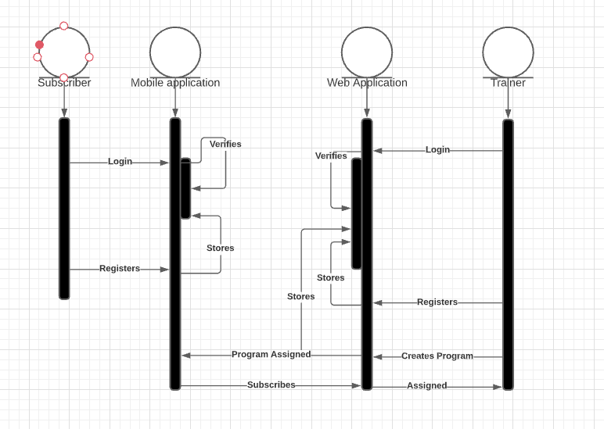

**5.1 Preliminary Design**

Initial primary color was #BAC0FF and a black font color of #000000, with whites of #F0F4F8. Color scheme was then presented to a user with said color codes. Please refer to the image below. User explained that the colors made the application seem “Very outdated”. The application seemed element of an early 2000’s app design wise. Color choices were then revisited. Research was done and it was shown “Dark Mode” was a very popular trend in 2020 for websites. Color scheme below was chosen to showcase this theme.

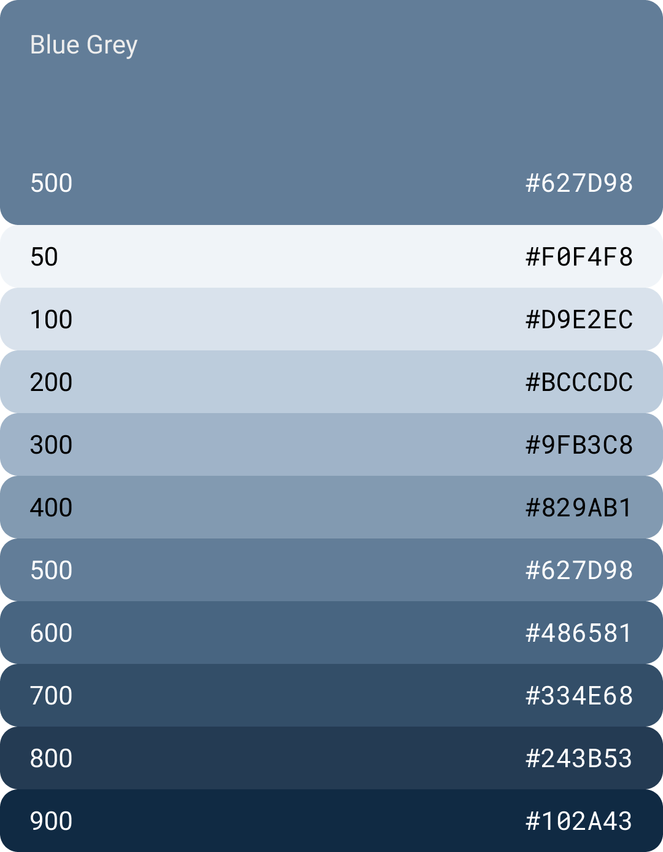

**5.2 User Effort Estimation**

Project duration is 16 weeks. A minimum of eight hours per week is required for the project. Rough estimate of total hours that will be needed for this project is 160 hours. 128 hours are the minimum required hours per week and 32 hours committed for project management meetings twice a week for an average duration of one hour. There will be a total of nine sprints. The first sprint will be one week to kick things off, and the following 8 sprints will last two weeks.

**6.1 Entity Relationship Diagram**

**7.1 Interface Specification**

Web application was to have a dashboard for easy navigation. Dashboard buttons included, clients, workouts, and routines. Upon clicking each one, it would take you to the respective page. Navbar also included for easy and quick navigation. In the clients page. Each client will have a details button containing their heart rate response to the programs. The routine page will have the ability to create a new route via a button. These routines will compose workouts stored in the databases. The workouts/exercises will contain an instructional gif on how to perform the exercise. The mobile application consists of three tabs, “Programs, “Search”, and “Profile”. The programs page will contain the workout along with its details. The search page will allow you to look up trainers and subscribe to them for their training and monitoring. The profile page will contain your heart rate response to the workouts as well as your personal information.

**7.2 State Diagram**

**8**

**9**